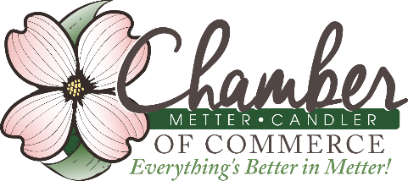
FARM FAMILY OF THE YEAR AWARD
Sponsored by the Chamber of Commerce
Agri-business Committee
2018 Official Entry Form
PURPOSE
The Metter-Candler Chamber of Commerce Agri-business Committee is selecting and honoring a farm family who best represents farming and ranching and the spirit of agriculture in Candler County.
ELIGIBILITY
The recipients must be actively engaged in farming with the majority of income derived from production agriculture. Deadline for this year is September 7, 2018.
HOW TO ENTER
Family is to complete this entry form. The entry must be typed or in clear print. It can be emailed to victoria@betterinmetter.com or mailed to the Metter-Candler Chamber of Commerce c/o Farm Family Entries, P.O. Box 497, Metter, GA 30459. Call Victoria Gaitten at 912-685-2159 or Jason Grimes at 912-687-5478 with questions regarding the award or entry process.
SELECTION PROCESS
Judges will be chosen by the Chamber Agri-business Committee and from the regional agri-business community and a winner will be selected from the entries received.
AWARD PRESENTATION
The Farm Family of the Year Award will be presented during the Candler County Harvest/Arts Festival to be held on September 22, 2018 in Downtown Metter.

PERSONAL INFORMATION for nomination:

Farm Name __________________________________________________________________

Owner Name ______________________________________________________________________

Address:__________________________________________________________________

Cell: _____________________Home Phone: ____________________________________

email:____________________________________________________________________

Number of Years In Farming:

______________________________________________________________

Other family members involved (parents, siblings, cousins, etc.):

_________________________________________________________________________

_________________________________________________________________________

Children involved in operation:

_________________________________________________________________________

FARMING HISTORY
Example: What year did your farming operation begin? What type of operation did it start out as? Was it owned, rented and how was it managed, etc.?

_________________________________________________________________________

_________________________________________________________________________

_________________________________________________________________________

_________________________________________________________________________

_________________________________________________________________________

_________________________________________________________________________

_________________________________________________________________________

CURRENT OPERATION
Example: Describe your operation (crops, livestock and other enterprises).

________________________________________________________________________

_________________________________________________________________________

_________________________________________________________________________

_________________________________________________________________________

_________________________________________________________________________

GOAL SETTING
Example: List goals you have established, such as to increase yields by 15 percent by using different types of seed, making more efficient use of the land, or increased weight gains in livestock, etc.
_________________________________________________________________________

_________________________________________________________________________

COMMUNITY INVOLVEMENT
Example: Describe involvement in community:

